**AIM: - Implementation of Bezier curve drawing**

**CODE: -**

**#include<iostream.h>**

**#include<graphics.h>**

**#include<math.h>**

**#include<conio.h>**

**#include<dos.h>**

**#define MAX 10**

**float mypower(float n,int k)**

**{**

**if(n==0.0)**

**return 1;**

**else**

**{**

**float power=1.0;**

**for(int i=1;i<=k;i++)**

**power*=n;**

**return power;**

**}**

**}**

**int fact(int n)**

**{**

**int prod = 1;**

**for(int i=n;i>1;i--)**

**prod*=i;**

**return prod;**

**}**

**int c(int n,int k)**

**{**

**return fact(n)/(fact(k)*fact(n-k));**

**}**

**float bez(int n,int k,float u)**

**{**

**return (c(n,k)*mypower(u,k)*mypower(1-u,n-k));**

**}**

**void main()**

**{**

**clrscr();**

**int px[MAX],py[MAX],n;**

**int gd=DETECT,gm;**

**initgraph(&gd,&gm,"c:\\turboc3\\bgi");**

**cout<<"Enter the number of control points\n";**

**cin>>n;**

**cout<<"Enter the points x\n";**

**for(int i=0;i<n;i++)**

**cin>>px[i];**

**cout<<"Enter the points y\n";**

**for(int j=0;j<n;j++)**

**cin>>py[j] ;**

**setcolor(5);**

**for(i=0;i<n-1;i++)**

**line(px[i],py[i],px[i+1],py[i+1]);**

**setcolor(15);**

**float u = 0.0;**

**while(u<=1)**

**{**

**float sumx=0,sumy=0;**

**for(int k=0;k<n;k++)**

**{**

**sumx+=px[k]*bez(n-1,k,u);**

**sumy+=py[k]*bez(n-1,k,u);**

**}**

**setcolor(15);**

**putpixel(sumx,sumy,RED);**

**u=u+0.005;**

**}getch();**

**}**

**OUTPUT:**

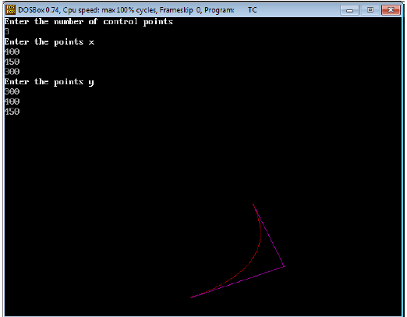

**Aim:- Implementation of B-spline curve drawing.**

**Code:**

**#include<iostream.h>**

**#include<conio.h>**

**#include<dos.h>**

**#include<math.h>**

**#include<graphics.h>**

**#include<stdlib.h>**

**#include<dos.h>**

**void Bspl(float& x,float& y,float px[],float py[],float u)**

**{**

**double u3=u*u*u;**

**double u2=u*u;**

**x=0;**

**x=x+u3*(-px[0]+3*px[1]-3*px[2]+px[3]);**

**x=x+u2*(3*px[0]-6*px[1]+3*px[2]);**

**x=x+u*(-3*px[0]+3*px[2]);**

**x=x+px[0]+4*px[1]+px[2];**

**x=x/6;**

**y=0;**

**y=y+u3*(-py[0]+3*py[1]-3*py[2]+py[3]);**

**y=y+u2*(3*py[0]-6*py[1]+3*py[2]);**

**y=y+u*(-3*py[0]+3*py[2]);**

**y=y+py[0]+4*py[1]+py[2];**

**y=y/6;**

**}**

**void main()**

**{**

**int gd,gm=DETECT;**

**clrscr();**

**detectgraph(&gd,&gm);**

**initgraph(&gd,&gm,"C:\\TurboC3\\BGI");**

**cout<<".............B-SPLINE CURVE...........";**

**int i,k,n1,cx[7],cy[7],midx,midy;**

**float px[4],py[4];**

**midx=getmaxx()/2;**

**midy=getmaxy()/2;**

**line(0,midy,getmaxx(),midy);**

**line(midx,0,midx,getmaxy());**

**n1=7;**

**cx[0]=-150;cy[0]=-50;**

**cx[1]=-100;cy[1]=50;**

**cx[2]=-50;cy[2]=-50;**

**cx[3]=0;cy[3]=50;**

**cx[4]=50;cy[4]=-50;**

**cx[5]=100;cy[5]=50;**

**cx[6]=150;cy[6]=-50;**

**//cx[7]=200;cy[7]=50;**

**for(i=0;i<n1-1;i++)**

**{**

**line(midx+cx[i],midy-cy[i],midx+cx[i+1],midy-cy[i+1]);**

**}**

**float x=0,y=0;**

**for(k=0;k<n1-3;k++)**

**{**

**px[0]=cx[k];py[0]=cy[k];**

**px[1]=cx[k+1];py[1]=cy[k+1];**

**px[2]=cx[k+2];py[2]=cy[k+2];**

**px[3]=cx[k+3];py[3]=cy[k+3];**

**for(float u=0.0;u<=1.0;u+=0.001)**

**{**

**Bspl(x,y,px,py,u);**

**putpixel(midx+x,midy-y,k+2);**

**}**

**}**

**getch();**

**closegraph();**

**}**

**OUTPUT:**

